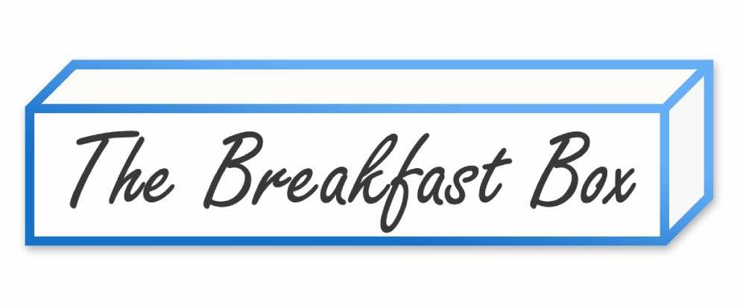
Name:
Phone:
Email:
Recipient Name (if different than above):
Recipient Phone (if different than above):
Date & Time of Event:
Event or Occasion:
Circle one: Pick Up Delivery
Delivery Address:
Number of Guests (See Below for pricing):
Allergies/Special Requests:
Build Your Own Box! (Pricing subject to change)

Please Circle your choice for each, 1-5:
1. Silver Dollar Pancakes OR Belgian Waffle Pieces
Served with Maple Syrup, Nutella & Fresh Whipped Cream
2. Vanilla Yogurt Parfaits OR Mini Bagels (Bagels served with Plain & Veggie Cream Cheese) OR Hearty Avocado Toast
3. Mini Pop Tarts OR Mini Doughnuts
4. Mini Muffins OR Mini Croissants
5. Candied Bacon OR Turkey Bacon OR Exotic Carved Fruit
Lines 6-9 & more are included in all of our boxes!
6. Fresh Carved Fruit & Berries
7. Candied Nuts
8. Dried Fruit Pieces

Standard Pricing (Taxes Apply):
Breakfast for 2… Starts @ $40 + Tax ($3.55)
Breakfast for 4… Starts @ $78 + Tax ($6.92)
Breakfast for 6… Starts @ $114 + Tax ($10.12)
Breakfast for 8… Starts @ $148 + Tax ($13.14)
Breakfast for 10… Starts @ $180 + Tax ($15.95)
Delivery Fee within 15 Miles… $20 + Tax
Local delivery within 15 Miles = $20… $1.25 per mile after.
NYS Tax calculated at 8.875%… $

Add On To your Breakfast Experience!
Item… Half Dozen… $$ Full Dozen… $$
Mini Bagels… $15.00… $28.00 (Choice of 2 Cream Cheeses)
Mini Donuts… $15.00… $28.00 (Choose up to 2 Flavors)
Mini Pop Tarts… $17.50… $32.00(Choose up to 2 Flavors)
Mini Croissants… $15.00… $28.00 (Combination of Plain & Choc.)
Mini Muffins… $15.00… $28.00 (Choose up to 2 Flavors)
Spinach Asiago Personal Quiche… $15.00… $28.00 (Choose up to 2 Flavors)
Full Sized Bagels… $24.00… $40.00 (Choice of Flavors) (Choice of 2 Cream Cheeses)

Early Arrival Fee Schedule
Arrival 7:30AM-8AM… $5
Arrival 7AM-7:30AM… $10
Arrival 6:30AM–7AM… $15
Arrival 6AM–6:30AM… $20
Arrival Earlier than 6AM ($MP)
*PLEASE NOTE: Holiday Delivery Times are not guaranteed! If you select and pay for Early Arrival we will do our very best to accommodate. If your breakfast does not arrive within the allotted delivery time, we’ll gladly issue a refund for the Early Arrival fee ONLY.

Happy Birthday Cake Topper, Shaped Cookies & More!… $5
Anniversary Packages… $5
Sympathy Packages… $10
Holiday Themed & Holiday Pricing… TBD
Full Sized Pop Tart (Frosted with Names, Dates & More)… $5.00

Coffee or Tea (Iced & Hot)… $4/pp
Hand-Squeezed Orange Juice… $3/pp
Smoothies (Ask about our seasonal flavors)… $7/pp
Mixed Berry | Strawberry Mango | Chocolate Strawberry

ORDER TOTAL = $
For Payment: Please Call with Credit Card or Send Venmo to @thebreakfastbox
*Charges will appear as “THE OAK NECK DELI”

Send your completed order forms back to us @ BreakfastBoxNY@gmail.com
Call or Text Doug @ 516 860 8708 with any Questions.
Thank you so much for your support!

